|  |
| --- |
| IFMR RURAL FINANCE |
| Application Review |
|  |
| **IFMR Rural Finance** |
| **10/26/2016** |

|  |
| --- |
|  |

Contents

Process Diagram 3

1. Stage definition 4

2. Stage-role access 4

3. Application Review Queue 4

3.1 UI specification 4

3.2 Screenshot 5

3.3 Functional requirements 6

3.4 Upload 6

3.5 Download 6

3.6 Reports 6

4. Capturing Application data 7

4.1 UI requirements 7

4.2 Screenshots 41

4.3 Functional requirements 70

4.4 Uploads 70

4.5 Downloads 70

4.6 Reports 70

# Process

1. Process Flowchart



1. Process Steps
2. Hub Manager logs in and will be able to view all profiles accepted in Application process
3. HM can search/sort based on following parameters

* Applicant Name
* Business Name
* URN
* Area
* City/Village/Town
* Pincode

1. All search parameters will have a sort/arrange facility
2. HM will click on the desired profile to select the customer. Application data of that customer will be auto-populated and Application review fields will be displayed.
3. HM will enter remarks based on application data.
4. HM will have the option to Hold/Reject/Sendback in addition to Accept.
5. If HM Accepts the application, it will move to next stage i.e Field Appraisal review
6. If HM holds the application, it will remain in queue with “on Hold” tag.
7. If HM Rejects the application, it will go to Rejected application queue
8. If HM chooses Sendback, he should get option to select one of the past stages (Application/Screening/Screening review in this case) and the application should move to that stage with “Sent Back from Application review stage” tag.

# Stage definition

|  |  |
| --- | --- |
| **Stage** | **Description** |
| Application Review Queue | The Hub Manager selects a profile from the pending for application review queue |
| Enter Remarks | The Hub Manager views the data presented, enters remarks and can either send back to any preceding stage for rework or submit to next stage (Field Appraisal) |

# Stage-role access

|  |  |
| --- | --- |
| **Stage** | **Applicable Role** |
| Application Review Queue | Hub Manager |
| Enter Remarks | Hub Manager |

# 

# Application Review Queue

## UI specification

|  |  |  |  |  |
| --- | --- | --- | --- | --- |
| **Field name** | **Section** | **Data Type** | **Attribute** | **Population logic** |
| S. No. | Application Review Queue | Numeric |  |  |
| Applicant Name | Application Review Queue | Text | Sort/search | From application stage |
| Business Name | Application Review Queue | Alphanumeric | Sort/search | From application stage |
| URN No | Application Review Queue | Alphanumeric | Sort/search | From application stage |
| Area | Application Review Queue | Text | Sort/search | From application stage |
| City/Village/ Town | Application Review Queue | Text | Sort/search | From application stage |
| Pincode | Application Review Queue | Numeric |  | From application stage |

## Screenshot

* + 1. Search Page

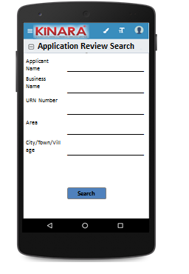

* + 1. Application Review Queue

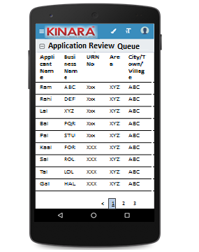

## Functional requirements

**Hub Manager** logs in

* The Hub Manager opens the process dash board, and clicks on Application Review Queue
* If the Hub Manager performs a search without selecting any parameter, then all cases with status ‘Pending for Application Review’ to be displayed in a tabular format.
* If the Hub Manager searches with ‘Applicant name’, ‘Business name’ or ‘URN no’, then all matching records that are ‘Pending for Application Review’ to be displayed in a tabular format.
* The Hub Manager can **search and sort** the profiles based on the following parameters: URN no, Applicant Name, Business Name, Area, City/Village/Town.
* The Hub Manager then selects a profile from the Application Review Queue. The queue table should have applicant name, business name, URN No, Area, City/Town/Village as column names.
* All the columns will have **sorting** facility.

## Upload

-NA-

## Download

-NA-

## Reports

-NA-

# Capturing Application data

## UI requirements

|  |  |  |  |  |  |  |  |  |  |  |  |  |  |  |  |
| --- | --- | --- | --- | --- | --- | --- | --- | --- | --- | --- | --- | --- | --- | --- | --- |
| **Entity** | **Tab** | | **Sub tab** | | | **Section** | | **Fields** | **Field Value** | | | **Mandatory** | **Conditional Mandatory** | **Remarks** | |
| **Application review** | Summary | | Risk Score | | |  | | (Screening Score) Risk Score 1 |  | | |  |  | From screening | |
|  | | (Application Score) Risk Score 2 |  | | |  |  | From application | |
|  | | Psychometric Score |  | | |  |  | From application | |
| CB Check Report | |  | | |  | | Applicant |  | | |  |  | Calculated at application stage | |
|  | | Co-applicant |  | | |  |  | Calculated at application stage | |
|  | | Business |  | | |  |  | Calculated at application stage | |
| APPLICANT | KYC Details | |  | | |  | | Aadhar No | Numeric | | | Yes |  | Auto-populated from application | |
| Document Capture | Upload | | | Yes |  | Auto-populated from application | |
| Pan Number | Alpha numeric | | | Yes |  | Auto-populated from application | |
| Document Capture | Upload | | | Yes |  | Auto-populated from application | |
| ID Type | Dropdown | | |  |  | Auto-populated from application | |
| ID No | Alpha numeric | | |  | Yes | Auto-populated from application | |
| Valid Up to | Date | | |  |  | Auto-populated from application | |
| Document Capture | Upload | | |  | Yes | Auto-populated from application | |
| Applicant Details | |  | | |  | | Title | Text | | | Yes |  | Auto-populated from application | |
| Name | Text | | | Yes |  | Auto-populated from application | |
| Gender | Text | | | Yes |  | Auto-populated from application | |
| Date Of birth | Text | | | Yes |  | Auto-populated from application | |
| Age | Text | | |  |  | Auto-populated from application | |
| Father's Name | Text | | | Yes |  | Auto-populated from application | |
| Educational Level | Dropdown | | | Yes |  | Auto-populated from application | |
| Religion | Dropdown | | | Yes |  | Auto-populated from application | |
| Mobile No | Numeric | | | Yes |  | Auto-populated from application | |
| Alternate Mobile No. | Numeric | | |  |  | Auto-populated from application | |
| WhatsApp Mobile No. | Radio Button | | |  |  | Auto-populated from application | |
| Email ID | Alphanumeric, special characters | | |  |  | Auto-populated from application | |
| Preferred language of communication | Dropdown | | | Yes |  | Auto-populated from application | |
| Mother's Name | Text | | |  |  | Auto-populated from application | |
| Marital Status | Dropdown | | | Yes |  | Auto-populated from application | |
| Spouse Name | Text | | |  |  | Auto-populated from application | |
| Relationship with Business | Dropdown | | | Yes |  | Auto-populated from application | |
| Business Involvement | Dropdown | | | Yes |  | Auto-populated from application | |
| Have you ever been a proprietor or partner of any other company | Radio Buttons | | |  |  | Auto-populated from application | |
| If yes, did the business close? | Radio Buttons | | |  |  | Auto-populated from application | |
| Month/Year (of business closure) | Date | | |  |  | Auto-populated from application | |
| Address Details | |  | | |  | | Type Of Address | Dropdown | | | Yes |  | Auto-populated from application | |
| Care of | Text | | |  |  | Auto-populated from application | |
| Building | Alphanumeric, special characters | | | Yes |  | Auto-populated from application | |
| Street | Alphanumeric, special characters | | |  |  | Auto-populated from application | |
| Landmark | Alphanumeric, special characters | | |  |  | Auto-populated from application | |
| Locality | Alphanumeric, special characters | | |  |  | Auto-populated from application | |
| Pincode | Text | | | Yes |  | Auto-populated from application | |
| Village/Town/City | Text | | | Yes |  | Auto-populated from application | |
| District | Text | | | Yes |  | Auto-populated from application | |
| State | Numeric | | | Yes |  | Auto-populated from application | |
| Country | Text | | | Yes |  | from screening but Editable | |
| Location | GPS coordinates | | | Yes |  | Auto-populated from application | |
| Is the Communication Address same as the Aadhar Card address? | Radio Buttons | | | Yes |  | Auto-populated from application | |
| Line 1 | Alpha numeric | | |  | Yes | Auto-populated from application | |
| Line 2 | Alpha numeric | | |  |  | Auto-populated from application | |
| Area | Alpha numeric | | |  |  | Auto-populated from application | |
| Land Mark | Alpha numeric | | |  | Yes | Auto-populated from application | |
| Pincode | Numeric | | |  | Yes | Auto-populated from application | |
| State | Text | | |  | Yes | Auto-populated from application | |
| District | Text | | |  | Yes | Auto-populated from application | |
| City/Town/Village | Text | | |  | Yes | Auto-populated from application | |
| Ownership | Dropdown | | | Yes |  | Auto-populated from application | |
| How many years are you living in present Area? | Dropdown | | | Yes |  | Auto-populated from application | |
| How many years are you living in current Address? | Dropdown | | | Yes |  | Auto-populated from application | |
| Is the Communication Address same as Permanent Address? | Radio Buttons | | | Yes |  | Auto-populated from application | |
| Family Member Details | |  | | |  | | Name | Text | | |  |  | Auto-populated from application | |
| Relationship with applicant | Dropdown | | |  |  | Auto-populated from application | |
| Profession | Dropdown | | |  |  | Auto-populated from application | |
| Salary | numeric | | |  |  | Auto-populated from application | |
| Education fee (annual) | numeric | | |  |  | Auto-populated from application | |
| Is a Co-applicant? | Radio Buttons | | |  |  | Auto-populated from application | |
| Household Financials | |  | | |  | | Other Income Source | Dropdown | | |  |  | Auto-populated from application | |
| Amount | Numeric | | |  |  | Auto-populated from application | |
| Expense Type | Dropdown | | |  |  | Auto-populated from application | |
| Amount | Numeric | | |  |  | Auto-populated from application | |
| Monthly Education Expenses | Auto Calculated | | |  |  | Auto-populated from application | |
| Family Exp. Based on Education expense | Auto Calculated | | |  |  | Auto-populated from application | |
| Asset Type | Dropdown | | |  |  | Auto-populated from application | |
| Vehicle make & model | Alphanumeric | | |  | Yes | Auto-populated from application | |
| Registered Owner | Alpha | | |  | Yes | Auto-populated from application | |
| Value of the asset | Numeric | | |  | Yes | Auto-populated from application | |
| Liabilities | |  | | |  | | Debt Source | Dropdown | | |  |  | Auto-populated from application | |
| Creditor's Name | Alphanumeric | | |  |  | Auto-populated from application | |
| Loan Amount | Numeric | | |  |  | Auto-populated from application | |
| Loan Outstanding | Numeric | | |  |  | Auto-populated from application | |
| Loan term | Alphanumeric | | |  |  | Auto-populated from application | |
| Monthly Instalment | Numeric | | |  |  | Auto-populated from application | |
| No. of instalment Paid | Numeric | | |  |  | Auto-populated from application | |
| Purpose | Dropdown | | |  |  | Auto-populated from application | |
| Bank Statement Details | |  | | |  | | IFSC Code | Alphanumeric | | | Yes |  | Auto-populated from application | |
| Bank Name | Alphanumeric | | |  |  | Auto-populated from application | |
| Branch Name | Text | | |  |  | Auto-populated from application | |
| A/C name | Alphanumeric | | | Yes |  | Auto-populated from application | |
| A/C type | Text | | | Yes |  | Auto-populated from application | |
| A/C no | Numeric | | | Yes |  | Auto-populated from application | |
| Banking since | Date | | |  |  | Auto-populated from application | |
| Net banking available | Radio Buttons | | | Yes |  | Auto-populated from application | |
| Sanctioned Amount | Numeric | | |  | Yes | Auto-populated from application | |
| Start Month | Date | | | Yes |  | Auto-populated from application | |
| Total Deposits | Numeric | | | Yes |  | Auto-populated from application | |
| Total Withdrawals | Numeric | | | Yes |  | Auto-populated from application | |
| Balance as on 15th | Numeric | | | Yes |  | Auto-populated from application | |
| No of cheques bounced | Numeric | | | Yes |  | Auto-populated from application | |
| No of EMI cheques bounced | Numeric | | | Yes |  | Auto-populated from application | |
| References | |  | | |  | | Reference Type | Dropdown | | | Yes |  | Auto-populated from application | |
| Full Name | Alphanumeric | | |  |  | Auto-populated from application | |
| Mobile No | Numeric | | |  |  | Auto-populated from application | |
| Occupation | Dropdown | | |  |  | Auto-populated from application | |
| Self-reported Income | Numeric | | |  |  | Auto-populated from application | |
| CO-APPLICANT | KYC Details | |  | | |  | | Aadhar No | Numeric | | | Yes |  | Auto-populated from application | |
| Document Capture | Upload | | | Yes |  | Auto-populated from application | |
| Pan Number | Alpha numeric | | | Yes |  | Auto-populated from application | |
| Document Capture | Upload | | | Yes |  | Auto-populated from application | |
| ID Type | Dropdown | | |  |  | Auto-populated from application | |
| ID No | Alpha numeric | | |  | Yes | Auto-populated from application | |
| Valid Up to | Date | | |  |  | Auto-populated from application | |
| Document Capture | Upload | | |  | Yes | Auto-populated from application | |
| Co-Applicant Details | |  | | |  | | Title | Text | | | Yes |  | Auto-populated from application | |
| Name | Text | | | Yes |  | Auto-populated from application | |
| Gender | Text | | | Yes |  | Auto-populated from application | |
| Date Of birth | Date | | | Yes |  | Auto-populated from application | |
| Age | Numeric | | |  |  | Auto-populated from application | |
| Father's Name | Text | | | Yes |  | Auto-populated from application | |
| Educational Level | Dropdown | | | Yes |  | Auto-populated from application | |
| Religion | Dropdown | | | Yes |  | Auto-populated from application | |
| Mobile No | Numeric | | | Yes |  | Auto-populated from application | |
| Alternate Mobile No. | Numeric | | |  |  | Auto-populated from application | |
| Whatsapp Mobile No. | Radio Button | | |  |  | Auto-populated from application | |
| Email ID | Alphanumeric, special characters | | |  |  | Auto-populated from application | |
| Preferred language of communication | Dropdown | | | Yes |  | Auto-populated from application | |
| Mothers Name | Text | | |  |  | Auto-populated from application | |
| Marital Status | Dropdown | | | Yes |  | Auto-populated from application | |
| Spouse Name | Text | | |  | Yes | Auto-populated from application | |
| Relationship with Applicant | Text | | | Yes |  | Auto-populated from application | |
| Relationship with Business | Dropdown | | | Yes |  | Auto-populated from application | |
| Business Involvement | Dropdown | | | Yes |  | Auto-populated from application | |
| Have you ever been a proprietor or partner of any other company | Radio Buttons | | |  |  | Auto-populated from application | |
| If yes, did the business close? | Radio Buttons | | |  |  | Auto-populated from application | |
| Month/Year (of business closure) | Date | | |  |  | Auto-populated from application | |
| Address Details | |  | | |  | | Type Of Address | Dropdown | | | Yes |  | Auto-populated from application | |
| Care of | Text | | |  |  | Auto-populated from application | |
| Building | Alphanumeric, special characters | | | Yes |  | Auto-populated from application | |
| Street | Alphanumeric, special characters | | |  |  | Auto-populated from application | |
| Landmark | Alphanumeric, special characters | | |  |  | Auto-populated from application | |
| Locality | Alphanumeric, special characters | | |  |  | Auto-populated from application | |
| Pincode | Text | | | Yes |  | Auto-populated from application | |
| Village/Town/City | Text | | | Yes |  | Auto-populated from application | |
| District | Text | | | Yes |  | Auto-populated from application | |
| State | Numeric | | | Yes |  | Auto-populated from application | |
| Country | Text | | | Yes |  | Auto-populated from application | |
| Location | GPS coordinates | | | Yes |  | Auto-populated from application | |
| Is the Communication Address same as the Aadhar Card address? | Radio Buttons | | | Yes |  | Auto-populated from application | |
| Line 1 | Alpha numeric | | |  | Yes | Auto-populated from application | |
| Line 2 | Alpha numeric | | |  |  | Auto-populated from application | |
| Area | Alpha numeric | | |  |  | Auto-populated from application | |
| Land Mark | Alpha numeric | | |  | Yes | Auto-populated from application | |
| Pincode | Numeric | | |  | yes | Auto-populated from application | |
| State | Auto populated | | |  | Yes | Auto-populated from application | |
| District | Auto populated | | |  | Yes | Auto-populated from application | |
| City/Town/Village | Auto populated | | |  | Yes | Auto-populated from application | |
| Location (GPS) | GPS coordinates | | | Yes |  | Auto-populated from application | |
| Landline Number | Numeric | | |  |  | Auto-populated from application | |
| Ownership | Dropdown | | | Yes |  | Auto-populated from application | |
| How many years are you living in present Area? | Dropdown | | | Yes |  | Auto-populated from application | |
| How many years are you living in current Address? | Dropdown | | | Yes |  | Auto-populated from application | |
| Is the Communication Address same as Permanent Address? | Radio Buttons | | | Yes |  | Auto-populated from application | |
| Family Member Details | |  | | |  | | Name | Text | | |  |  | Auto-populated from application | |
| Relationship with co-applicant | Text | | |  |  | Auto-populated from application | |
| Profession | Text | | |  |  | Auto-populated from application | |
| Salary | Numeric | | |  |  | Auto-populated from application | |
| Education fee (annual) | Numeric | | |  |  | Auto-populated from application | |
| Household Financials | |  | | |  | | Other Income Source | Dropdown | | |  |  | Auto-populated from application | |
| Amount | Numeric | | |  |  | Auto-populated from application | |
| Expense Type | Dropdown | | |  |  | Auto-populated from application | |
| Amount | Numeric | | |  |  | Auto-populated from application | |
| Monthly Education Expenses | Auto Calculated | | |  |  | Auto-populated from application | |
| Family Exp. Based on Education expense | Auto Calculated | | |  |  | Auto-populated from application | |
| Asset Type | Dropdown | | |  |  | Auto-populated from application | |
| Vehicle make & model | Alphanumeric | | |  | Yes | Auto-populated from application | |
| Registered Owner | Alpha | | |  | Yes | Auto-populated from application | |
| Value of the asset | Numeric | | |  | Yes | Auto-populated from application | |
| Bank Statement Details | |  | | |  | | IFSC Code | Alphanumeric | | | Yes |  | Auto-populated from application | |
| Bank Name | Alphanumeric | | |  |  | Auto-populated from application | |
| Branch Name | Text | | |  |  | Auto-populated from application | |
| A/C name | Alphanumeric | | | Yes |  | Auto-populated from application | |
| A/C type | Text | | | Yes |  | Auto-populated from application | |
| A/C no | Numeric | | | Yes |  | Auto-populated from application | |
|
| Banking since | Date | | |  |  | Auto-populated from application | |
| Net banking available | Radio Buttons | | | Yes |  | Auto-populated from application | |
| Sanctioned Amount | Numeric | | |  | Yes | Auto-populated from application | |
| Start Month | Date | | | Yes |  | Auto-populated from application | |
| Total Deposits | Numeric | | | Yes |  | Auto-populated from application | |
| Total Withdrawals | Numeric | | | Yes |  | Auto-populated from application | |
| Balance as on 15th | Numeric | | | Yes |  | Auto-populated from application | |
| No of cheques bounced | Numeric | | | Yes |  | Auto-populated from application | |
| No of EMI cheques bounced | Numeric | | | Yes |  | Auto-populated from application | |
| GUARANTOR | KYC Details | |  | | |  | | Aadhar No | Numeric | | | Yes |  | Auto-populated from application | |
| Document Capture | Upload | | | Yes |  | Auto-populated from application | |
| Pan Number | Alpha numeric | | | Yes |  | Auto-populated from application | |
| Document Capture | Auto populate/Upload | | | Yes |  | Auto-populated from application | |
| ID Type | Dropdown | | |  |  | Auto-populated from application | |
| ID No | Alpha numeric | | |  | Yes | Auto-populated from application | |
| Valid up to | Date | | |  |  | Auto-populated from application | |
| Document Capture | Upload | | | Yes | Yes | Auto-populated from application | |
| Guarantor Details | |  | | |  | | Title | Text | | | Yes |  | Auto-populated from application | |
| Name | Text | | | Yes |  | Auto-populated from application | |
| Gender | Text | | | Yes |  | Auto-populated from application | |
| Date Of birth | Date | | | Yes |  | Auto-populated from application | |
| Age | Numeric | | |  |  | Auto-populated from application | |
| Father's Name | Text | | | Yes |  | Auto-populated from application | |
| Educational Level | Dropdown | | | yes |  | Auto-populated from application | |
| Religion | Dropdown | | | Yes |  | Auto-populated from application | |
| Mobile No | Numeric | | | Yes |  | Auto-populated from application | |
| Alternate Mobile No. | Numeric | | |  |  | Auto-populated from application | |
| WhatsApp Mobile No. | Radio button , Numeric | | |  |  | Auto-populated from application | |
| Email ID | Alphanumeric, special characters | | |  |  | Auto-populated from application | |
| Preferred language of communication | Dropdown | | | Yes |  | Auto-populated from application | |
| Mother's Name | Text | | |  |  | Auto-populated from application | |
| Marital Status | Dropdown | | | Yes |  | Auto-populated from application | |
| Spouse Name | Text | | |  | Yes | Auto-populated from application | |
| Relationship with Applicant | Dropdown | | | Yes |  | Auto-populated from application | |
| Business Involvement | Dropdown | | | Yes |  | Auto-populated from application | |
| Have you ever been a proprietor or partner of any other company | Radio Buttons | | |  |  | Auto-populated from application | |
| If yes, did the business close? | Radio Buttons | | |  |  | Auto-populated from application | |
| Month/Year (of business closure) | Date | | |  |  | Auto-populated from application | |
| Address Details | |  | | |  | | Type Of Address | Dropdown | | | Yes |  | Auto-populated from application | |
| Care of | Text | | |  |  | Auto-populated from application | |
| Building | Alphanumeric, special characters | | | Yes |  | Auto-populated from application | |
| Street | Alphanumeric, special characters | | |  |  | Auto-populated from application | |
| Landmark | Alphanumeric, special characters | | |  |  | Auto-populated from application | |
| Locality | Alphanumeric, special characters | | |  |  | Auto-populated from application | |
| Pincode | Text | | | Yes |  | Auto-populated from application | |
| Village/Town/City | Text | | | Yes |  | Auto-populated from application | |
| District | Text | | | Yes |  | Auto-populated from application | |
| State | Numeric | | | Yes |  | Auto-populated from application | |
| Country | Text | | | Yes |  | Auto-populated from application | |
| Is the Communication Address same as the Aadhar Card address? | Radio Buttons | | | Yes |  | Auto-populated from application | |
| Line 1 | Alpha numeric | | |  | Yes | Auto-populated from application | |
| Line 2 | Alpha numeric | | |  |  | Auto-populated from application | |
| Area | Alpha numeric | | |  |  | Auto-populated from application | |
| Land Mark | Alpha numeric | | |  | Yes | Auto-populated from application | |
| Pincode | Numeric | | |  | Yes | Auto-populated from application | |
| State | Auto populated | | |  | Yes | Auto-populated from application | |
| District | Auto populated | | |  | Yes | Auto-populated from application | |
| City/Town/ Village | Auto populated | | |  | Yes | Auto-populated from application | |
| Location (GPS) | GPS coordinates | | | Yes |  | Auto-populated from application | |
| Ownership | Dropdown | | | Yes |  | Auto-populated from application | |
| How many years are you living in present Area? | Dropdown | | | Yes |  | Auto-populated from application | |
| How many years are you living in current Address? | Dropdown | | | Yes |  | Auto-populated from application | |
| Is the Communication Address same as Permanent Address? | Radio Buttons | | | Yes |  | Auto-populated from application | |
| BUSINESS | Business Detail | |  | | |  | | Referred by | Dropdown | | | Yes |  | Auto-populated from application | |
| Referred Name | Text | | |  | Yes (Based on the dropdown) | Auto-populated from application | |
| Business Name | Text | | | Yes |  | Auto-populated from application | |
| Business type | Dropdown | | | Yes |  | Auto-populated from application | |
| Business Activity | Radio Buttons | | | Yes |  | Auto-populated from application | |
| Business Sector | Text | | | Yes |  | Auto-populated from application | |
| Business Sub sector | Text | | | Yes |  | Auto-populated from application | |
| ITR available? | Radio Buttons | | |  |  | Auto-populated from application | |
| Business Operating since | Date | | |  |  | Auto-populated from application | |
| Is the Business Registered? | Radio Buttons | | | Yes |  | Auto-populated from application | |
| Business Registration Type | Dropdown | | |  | Yes | Auto-populated from application | |
| Business Registration Proof No | Alpha numeric | | |  | Yes | Auto-populated from application | |
| Business Registration Date | Date | | |  | Yes | Auto-populated from application | |
| Valid up to | Date | | |  | Yes | Auto-populated from application | |
| Document Capture | Upload | | |  | Yes | Auto-populated from application | |
| Constitution | Dropdown | | |  |  | Auto-populated from application | |
| If partnership, how many total partners | Dropdown | | |  | Yes | Auto-populated from application | |
| Has anyone else been a partner of your present business | Radio Buttons | | |  |  | Auto-populated from application | |
| If yes, when was that partnership dissolved? | Date | | |  | Dissolution Agreement required | Auto-populated from application | |
| Address Details | |  | | |  | | Line 1 | Alpha numeric | | | yes |  | Auto-populated from application | |
| Line 2 | Alpha numeric | | |  |  | Auto-populated from application | |
| Pin Code (Search Option) | Numeric | | | yes |  | Auto-populated from application | |
| Land Mark | Text | | | yes |  | Auto-populated from application | |
| State (Auto populate) | Auto populated | | | yes |  | Auto-populated from application | |
| District(Auto populate) | Auto populated | | | yes |  | Auto-populated from application | |
| City/Village | Auto populated | | | yes |  | Auto-populated from application | |
| Location (GPS) | GPS coordinates | | | yes |  | Auto-populated from application | |
| Ownership (Owned/Rent/Lease) | Dropdown | | | yes |  | Auto-populated from application | |
| How many years business in present Area? | Dropdown | | | yes |  | Auto-populated from application | |
| How many years business in current address? | Dropdown | | | yes |  | Auto-populated from application | |
| Employee Detail | |  | | |  | | No of Male Employees | Numeric | | |  |  | Auto-populated from application | |
| No of Female Employees | Numeric | | |  |  | Auto-populated from application | |
| Average Monthly Salary | Numeric | | |  |  | Auto-populated from application | |
| Buyer Detail | |  | | |  | | Buyer Name | Alpha numeric | | |  | Yes | Auto-populated from application | |
| Customer Since | Dropdown | | |  | Yes | Auto-populated from application | |
| Sector | Dropdown | | |  | Yes | Auto-populated from application | |
| Sub Sector | Dropdown | | |  | Yes | Auto-populated from application | |
| Product | alpha numeric | | |  |  | Auto-populated from application | |
| Payment terms (days) | numeric | | |  |  | Auto-populated from application | |
| Payment date | Date | | |  |  | Auto-populated from application | |
| Payment Frequency | Dropdown | | |  |  | Auto-populated from application | |
| Receivables Outstanding / Customer Credit | numeric | | |  |  | Auto-populated from application | |
| Business Financials | | Income | | | Through Sales | | Buyer Name | Dropdown | | |  |  | Auto-populated from application | |
| Income type | Radio Buttons | | |  |  | Auto-populated from application | |
| Amount | Numeric | | |  |  | Auto-populated from application | |
| Date | Date | | |  |  | Auto-populated from application | |
| Other Business Income | | Income Source | Dropdown | | |  |  | Auto-populated from application | |
| Amount | Numeric | | |  |  | Auto-populated from application | |
| Date | Date | | |  |  | Auto-populated from application | |
| Expenses | | | Raw material expense | | Vendor Name | Alphanumeric | | |  | Yes | Auto-populated from application | |
| Type | Radio Buttons | | |  |  | Auto-populated from application | |
| Amount | Numeric | | |  |  | Auto-populated from application | |
| Date | Date | | |  |  | Auto-populated from application | |
| Salary and Wages | | Owner's Salary | Numeric | | |  |  | Auto-populated from application | |
| Co- Owner's Salary | Numeric | | |  |  | Auto-populated from application | |
| Employee's Salary | Numeric | | |  |  | Auto-populated from application | |
| Fixed Obligations | | Payment of Debts | Numeric | | |  |  | Auto-populated from application | |
| Savings/Committee/Chits | Numeric | | |  |  | Auto-populated from application | |
| Insurance Premium amount | Numeric | | |  |  | Auto-populated from application | |
| Other Expenses | | Rent | Numeric | | |  |  | Auto-populated from application | |
| Sub-Contractor Payment | Numeric | | |  |  | Auto-populated from application | |
| Tools & Consumables | Numeric | | |  |  | Auto-populated from application | |
| Electricity Charges | Numeric | | |  |  | Auto-populated from application | |
| Transportation Costs | Numeric | | |  |  | Auto-populated from application | |
| Repair and Maintenance | Numeric | | |  |  | Auto-populated from application | |
| General Admin | Numeric | | |  |  | Auto-populated from application | |
| Assets | | | Current Assets | | Cash At Bank | Numeric | | |  |  | Auto-populated from application | |
| Inventory | | Raw Material | Numeric | | |  |  | Auto-populated from application | |
| WIP | Numeric | | |  |  | Auto-populated from application | |
| Finished Goods | Numeric | | |  |  | Auto-populated from application | |
| Machinery | | Machine Description | Alphanumeric | | |  | Yes | Auto-populated from application | |
| Manufacturer Name | Alphanumeric | | |  |  | Auto-populated from application | |
| Machine Type | Dropdown | | |  |  | Auto-populated from application | |
| Machine Model | Alphanumeric | | |  |  | Auto-populated from application | |
| Serial Number | Alphanumeric | | |  |  | Auto-populated from application | |
| Purchase Price | Numeric | | |  |  | Auto-populated from application | |
| Machine Purchased Year | Numeric | | |  |  | Auto-populated from application | |
| Present Value | Numeric | | |  |  | Auto-populated from application | |
| Is the Machine New? | Radio Buttons | | |  |  | Auto-populated from application | |
| Funding Source | Dropdown | | |  |  | Auto-populated from application | |
| Is the Machine Hypothecated? | Radio Buttons | | |  |  | Auto-populated from application | |
| Machine Permanently fixed to building? | Radio Buttons | | |  |  | Auto-populated from application | |
| Machine Bills | Upload | | |  | Yes | Auto-populated from application | |
| Other Fixed assets | | Asset Type | Dropdown | | |  |  | Auto-populated from application | |
| Vehicle Make & Model (if asset type is vehicle) | Alphanumeric | | |  | Yes | Auto-populated from application | |
| Value of Asset | Numeric | | |  |  | Auto-populated from application | |
| Company Liabilities | | |  | | Debt Source | Dropdown | | |  |  | Auto-populated from application | |
| Creditor's Name | Alphanumeric | | |  |  | Auto-populated from application | |
| Loan Amount | Numeric | | |  |  | Auto-populated from application | |
| Loan Outstanding | Numeric | | |  |  | Auto-populated from application | |
| Loan term | Alphanumeric | | |  |  | Auto-populated from application | |
| Monthly Instalment | Numeric | | |  |  | Auto-populated from application | |
| No. Of instalment Paid | Numeric | | |  |  | Auto-populated from application | |
| Purpose | Dropdown | | |  |  | Auto-populated from application | |
| Supplier's Name | Alphanumeric | | |  |  | Auto-populated from application | |
| Type | Dropdown | | |  |  | Auto-populated from application | |
| Payment terms (days) | Numeric | | |  |  | Auto-populated from application | |
| Amount | Numeric | | |  |  | Auto-populated from application | |
| Financial Summary | | |  | | Sales | Numeric | | |  |  | Auto Calculated field – Formula to be shared by Kinara | |
| Purchases | Numeric | | |  |  | Auto Calculated field – Formula to be shared by Kinara | |
| Operating Expenses | Numeric | | |  |  | Auto Calculated field – Formula to be shared by Kinara | |
| Household Expenses | Numeric | | |  |  | Auto Calculated field – Formula to be shared by Kinara | |
| Fixed Obligations | Numeric | | |  |  | Auto Calculated field – Formula to be shared by Kinara | |
| Net Business Income | Numeric | | |  |  | Auto Calculated field – Formula to be shared by Kinara | |
| Bank Statement Details | |  | | |  | | IFSC Code | Alphanumeric | | | Yes |  | Auto-populated from application | |
| Bank Name | Alphanumeric | | |  |  | Auto-populated from application | |
| Branch Name | Text | | |  |  | Auto-populated from application | |
| A/C name | Alphanumeric | | | Yes |  | Auto-populated from application | |
| A/C type | Text | | | Yes |  | Auto-populated from application | |
| A/C no | Numeric | | | Yes |  | Auto-populated from application | |
| Banking since | Date | | |  |  | Auto-populated from application | |
| Net banking available | Radio Buttons | | | Yes |  | Auto-populated from application | |
| Sanctioned Amount | Numeric | | |  | Yes | Auto-populated from application | |
| Start Month | Date | | | Yes |  | Auto-populated from application | |
| Total Deposits | Numeric | | |  |  | Auto-populated from application | |
| Total Withdrawals | Numeric | | |  |  | Auto-populated from application | |
| Balance as on 15th | Numeric | | |  |  | Auto-populated from application | |
| No of cheques bounced | Numeric | | |  |  | Auto-populated from application | |
| No of EMI cheques bounced | Numeric | | |  |  | Auto-populated from application | |
| References | |  | | |  | | Reference type | Dropdown | | | Yes |  | Auto-populated from application | |
| Business Name | Alpha numeric | | |  |  | Auto-populated from application | |
| Full name of POC | Alpha numeric | | |  |  | Auto-populated from application | |
| Mobile No | Numeric | | |  |  | Auto-populated from application | |
| Business Sector | Dropdown | | |  |  | Auto-populated from application | |
| Business sub sector | Dropdown | | |  |  | Auto-populated from application | |
| Self-reported Income | Numeric | | |  |  | Auto-populated from application | |
| LOAN DETAILS | Loan Proposal | |  | | |  | | Purpose | Dropdown | | | Yes |  | Auto-populated from application | |
| Sub-purpose | Dropdown | | | Yes |  | Auto-populated from application | |
| Do you have assets available for hypothecation | Radio Buttons | | |  |  | Auto-populated from application | |
| If yes, estimated value of assets | Numeric | | |  | Yes | Auto-populated from application | |
| Loan Amount | Numeric | | | Yes |  | Auto-populated from application | |
| Term | Numeric | | | Yes |  | Auto-populated from application | |
| EMI Requested | Numeric | | | Yes |  | Auto-populated from application | |
| EMI Payment Date Requested | Date | | |  |  | Auto-populated from application | |
| Frequency | Dropdown | | | Yes |  | Auto-populated from application | |
| Expected Interest Rate | Numeric | | | Yes |  | Auto-populated from application | |
| Estimated Kinara EMI | Numeric | | | Yes |  | Auto-populated from application | |
| Estimated date of Completion | Date | | |  |  | Auto-populated from application | |
| Product Type | Dropdown | | |  |  | Auto-populated from application | |
| Customer sign date | Date | | | Yes |  | Auto-populated from application | |
| New Asset Details | |  | | |  | | Machine | Alphanumeric | | |  | Yes | Auto-populated from application | |
| Purchase Price | Numeric | | |  |  | Auto-populated from application | |
| Expected Income | Numeric | | |  |  | Auto-populated from application | |
| Manufacturer Name | Alphanumeric | | |  |  | Auto-populated from application | |
| Machine Type | Dropdown | | |  |  | Auto-populated from application | |
| Machine Model | Alphanumeric | | |  |  | Auto-populated from application | |
| Serial No | Alphanumeric | | |  |  | Auto-populated from application | |
| Expected purchase date | Date | | |  |  | Auto-populated from application | |
| Machine Permanently fixed to building | Radio Buttons | | |  |  | Auto-populated from application | |
| Hypothecated to Kinara | Dropdown | | |  |  | Auto-populated from application | |
| Remarks | |  | |  |  | | Hub Manager Remarks | | | Alphanumeric |  | |  | | Free text |

**Details of Conditional Drop-downs**

1. **Business Type- Manufacturing**

|  |  |  |  |
| --- | --- | --- | --- |
| **Business Type** | **Business Activity** | **Business Sector** | **Business Sub Sector** |
| Manufacturing | Sales | Machine Components |  |
|  | Job Work |  | Agriculture Machinery |
|  | Job work & Sales |  | Satellite Equipment |
|  |  |  | Construction Equipment |
|  |  |  | Textile Machinery |
|  |  |  | Plastics Machinery |
|  |  |  | Chemical Processing Machinery |
|  |  |  | Paper & Paperboard making machinery |
|  |  |  | Food Manufacturing Machinery |
|  |  |  | Semi-conductor Machinery |
|  |  |  | Wire Cutting Machinery |
|  |  |  | Automation Machinery |
|  |  |  | Special Purpose Machinery |
|  |  |  | Aircraft/Defence Machines |
|  |  |  | Air conditioning/Heating |
|  |  |  | Elevator/Conveyor |
|  |  |  | Ovens/Furnaces |
|  |  |  | Office Machinery/Equipment |
|  |  |  | Pumps/Compressors/Valves |
|  |  |  | Power Equipment |
|  |  |  | General Purpose Machinery |
|  |  | Auto Components | 2-Wheelers |
|  |  |  | 4-Wheelers |
|  |  |  | Light Commercial Vehicles (utility trucks, pickups, etc) |
|  |  |  | Heavy Commercial Vehicles (Trucks/Lorries) |
|  |  |  | Passenger Vehicles (Vans, Buses) |
|  |  |  | Agriculture Vehicles (Tractors, Tillers) |
|  |  |  | Construction Vehicles (Bobcats, Loaders, Compactors, Drillers, Earth-moving, etc.) |
|  |  | Fabrication | Welding |
|  |  |  | Tool & Dies |
|  |  | Food Products | Dairy Products |
|  |  |  | Beverage |
|  |  |  | Oils |
|  |  |  | Grain Mills |
|  |  |  | Animal Feed |
|  |  |  | Processing/Preserving meat, fish, vegetables |
|  |  |  | Starch and Starch Products |
|  |  |  | Bakery Goods |
|  |  |  | Prepared Meals & Dishes |
|  |  | Leather | Tanning & Dyeing |
|  |  |  | Footwear |
|  |  |  | Luggage |
|  |  |  | Handbags |
|  |  | Wood | Sawmill |
|  |  |  | Wood Materials |
|  |  |  | Furniture |
|  |  |  | Household goods |
|  |  | Textiles | Spinning |
|  |  |  | Weaving |
|  |  |  | Bleaching |
|  |  |  | Dyeing |
|  |  |  | Dressing |
|  |  |  | Drying |
|  |  |  | Steaming |
|  |  |  | Shrinking |
|  |  |  | Printing |
|  |  | Apparel | Knitwear |
|  |  |  | Ethnic Wear |
|  |  |  | Western Wear |
|  |  |  | Underwear |
|  |  | Paper | Paper Recycling |
|  |  |  | Pulp making |
|  |  |  | Paper & Paper Rolls |
|  |  |  | Paper Products (cups, plates, toys, etc.) |
|  |  |  | Cardboard Paper Products |
|  |  |  | Corrugated Paper Products |
|  |  |  | Carbon Paper & Stationary Items |
|  |  | Printing | Packaging Printing |
|  |  |  | Publication Printing |
|  |  |  | Commercial Printing |
|  |  | Plastics | Plastic Recycling |
|  |  |  | Industrial Injection Moulding |
|  |  |  | Household Injection Moulding |
|  |  |  | Plastic Sheets and Films |
|  |  |  | Plastic Packaging (bags, boxes, cases, et) |
|  |  |  | Optical (eye glass frames, etc.) |
|  |  |  | Housewares |
|  |  |  | Pipes, Tubes and Fittings |
|  |  |  | Other Plastic Moulding & Extrusion |
|  |  |  | Plastic Furniture |
|  |  |  | Medical & Dental Appliances |
|  |  |  | Games & Toys |
|  |  |  | Writing (pens, desk stuff, etc.) |
|  |  |  | Sanitary (tubs, basins, etc.) |
|  |  |  | Travel Goods (luggage, bags, etc.) |
|  |  | Electronics | Electronic Components |
|  |  |  | Computer Components |
|  |  |  | Communication Equipment |
|  |  |  | Measuring & Testing Equipment |
|  |  |  | Optical Instruments |
|  |  |  | Electro-medical Equipment |
|  |  | Electrical | Control Panels |
|  |  |  | Motors |
|  |  |  | Generators |
|  |  |  | Batteries/Accumulators |
|  |  |  | Wiring and Wiring Devices |
|  |  |  | Lighting Equipment |
|  |  |  | Domestic Appliances |
|  |  | Medical Equipment | Medical Instruments |
|  |  |  | Dental Instruments |
|  |  |  | Hospital Equipment |
|  |  | Chemicals | Basic Chemicals |
|  |  |  | Fertilizers & Nitrogen Compounds |
|  |  |  | Plastics & Synthetic Rubber |
|  |  |  | Pesticides & Agro-chemicals |
|  |  |  | Paints, Varnishes, Coatings, Enamels & Lacquer |
|  |  |  | Soap & Detergents |
|  |  | Pharmaceuticals | Antibiotics, Serums, Vitamins |
|  |  |  | Ayurvedic Preparations |
|  |  |  | Homeopathic Preparations |
|  |  |  | Veterinary Preparations |
|  |  |  | Gauze, Bandages, Dressings |
|  |  | Rubber | Rubber Tyres and Tubes |
|  |  |  | Tyre and Tube Repair |
|  |  |  | Elastic Fabrics |
|  |  |  | Footwear |
|  |  |  | Glues & Adhesives |
|  |  |  | Rubber Sports Equipment |
|  |  |  | Boats & Rafts |
|  |  |  | Games & Toys & Balloons |
|  |  |  | Rubber Fittings (plates, sheets, rods, hoses) |

1. **Business Type-Trading**

|  |  |  |  |
| --- | --- | --- | --- |
| **Business Type** | **Business Line** | **Business Sector** | **Business Sub Sector** |
| Trading | Whole Sale | Automobiles | Auto Accessories |
| Retail | Automobiles | Auto Parts |
|  |  | Automobiles | Auto Tyres |
|  |  | Book Stores | Book Stores |
|  |  | Construction | Painting |
|  |  | Construction | Cement |
|  |  | Electricals | Electricals |
|  |  | Electricals | Lighting stores |
|  |  | Electronics | Camera stores |
|  |  | Electronics | Computers/tech shops |
|  |  | Electronics | Home appliances |
|  |  | Electronics | Kitchen appliances |
|  |  | Housewares | Kitchen Goods |
|  |  | Electronics | Mobile shops |
|  |  | Fashion | Baby products |
|  |  | Fashion | Clothing stores |
|  |  | Fashion | Luggage stores |
|  |  | Fashion | Shoe stores |
|  |  | Food & Beverage | Fruit/Veg Stands |
|  |  | Food & Beverage | Provision stores |
|  |  | Food & Beverage | Water Suppliers |
|  |  | Food & Beverage | Snack Shops |
|  |  | Food & Beverage | Sweet Shops |
|  |  | Food & Beverage | Ice-cream shops |
|  |  | Furniture | Wood Furniture |
|  |  | Furniture | Steel Furniture |
|  |  | Furniture | Plastic Furniture |
|  |  | Health & Beauty | Beauty Products |
|  |  | Health & Beauty | Eyewear stores |
|  |  | Health & Beauty | Health food stores |
|  |  | Health & Beauty | Jewellery stores |
|  |  | Health & Beauty | Pharmacy |
|  |  | Health & Beauty | Ayurvedic Medical |
|  |  | Health & Beauty | Homeopathic Medical |
|  |  | Health & Beauty | Sports equipment |
|  |  | Hobbies | Art and crafts store |
|  |  | Hobbies | Musical instruments |
|  |  | Hobbies | Pet goods store |
|  |  | Hobbies | Video stores |
|  |  | Housewares | Home Decor & Gifts |
|  |  | Housewares | Watch and clocks |
|  |  | Industrial | Industrial products |
|  |  | Industrial | Scrap Dealers |
|  |  | Stationary | Stationary |

1. **Business Type-Services**

|  |  |  |  |
| --- | --- | --- | --- |
| **Business Type** | **Business Line** | **Business Sector** | **Business Sub Sector** |
| Services | Retail (Business to Consumer) | Automobiles | Car Maintenance Services |
| Retail (Business to Business) | Automobiles | Tyre Retreading |
|  |  | Education | Education |
|  |  | Health & Beauty | Beauty/Hair |
|  |  | Health & Beauty | Diagnostics |
|  |  | Health & Beauty | Gym/Fitness |
|  |  | Health & Beauty | Salons |
|  |  | Home Care | Appliance Repair |
|  |  | Home Care | Carpentry |
|  |  | Home Care | Cleaning |
|  |  | Home Care | Construction |
|  |  | Home Care | Gardening |
|  |  | Home Care | Movers |
|  |  | Home Care | Painting |
|  |  | Home Care | Pest Control |
|  |  | Home Care | Plumbing |
|  |  | Industrial | Electro-plating |
|  |  | Industrial | Hydro-plating |
|  |  | Industrial | Heat Treatment |
|  |  | Industrial | Industrial Gases |
|  |  | Industrial | Waste & Water Management |
|  |  | Professional | Advertising |
|  |  | Professional | Dry Cleaning/Laundry |
|  |  | Professional | Event Planning |
|  |  | Professional | Financial |
|  |  | Professional | Legal |
|  |  | Professional | Medical |
|  |  | Professional | Opticians |
|  |  | Professional | Real Estate |
|  |  | Software & Tech | Graphic Design |
|  |  | Software & Tech | Software |
|  |  | Software & Tech | Telecommunication |
|  |  | Travel | Hotels |
|  |  | Travel | Restaurants |
|  |  | Travel | Tourism/Travel |
|  |  | Travel | Transport |

## Screenshots

UI layout: When Application Review is clicked the following screen will be displayed. This is also the first screen that will be displayed when a particular customer URN is clicked.

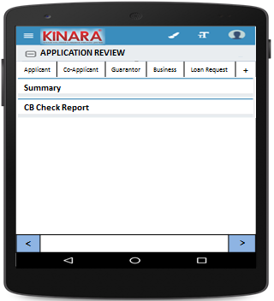

4.2(A) Summary

The initial Summary screen will look as below- with 1 sub-tab

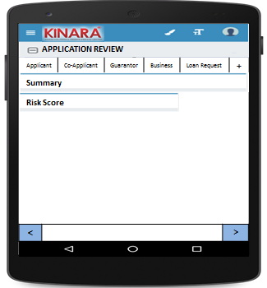

4.2(A1) Risk Score

|  |  |  |
| --- | --- | --- |
| Page 1 –Risk Score initial screen | Page 2- Screening score | Page 3 – Psychometric Score |

4.2(B) CB Check Report

CB report for each entity will be displayed under their respective tabs, as below.

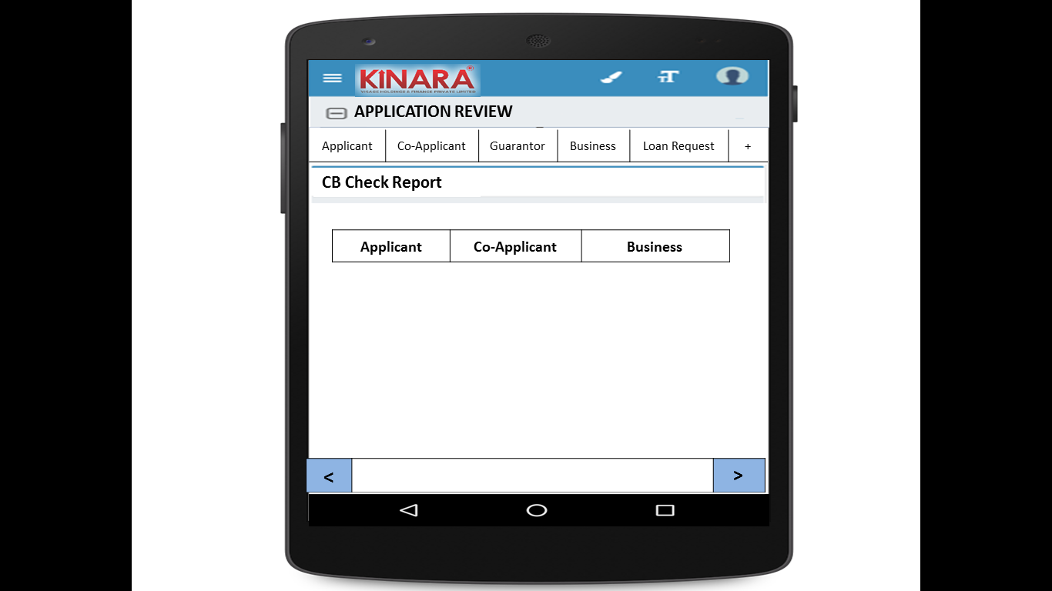

**4.2.1 Applicant**

Entity wise data display will start with Applicant

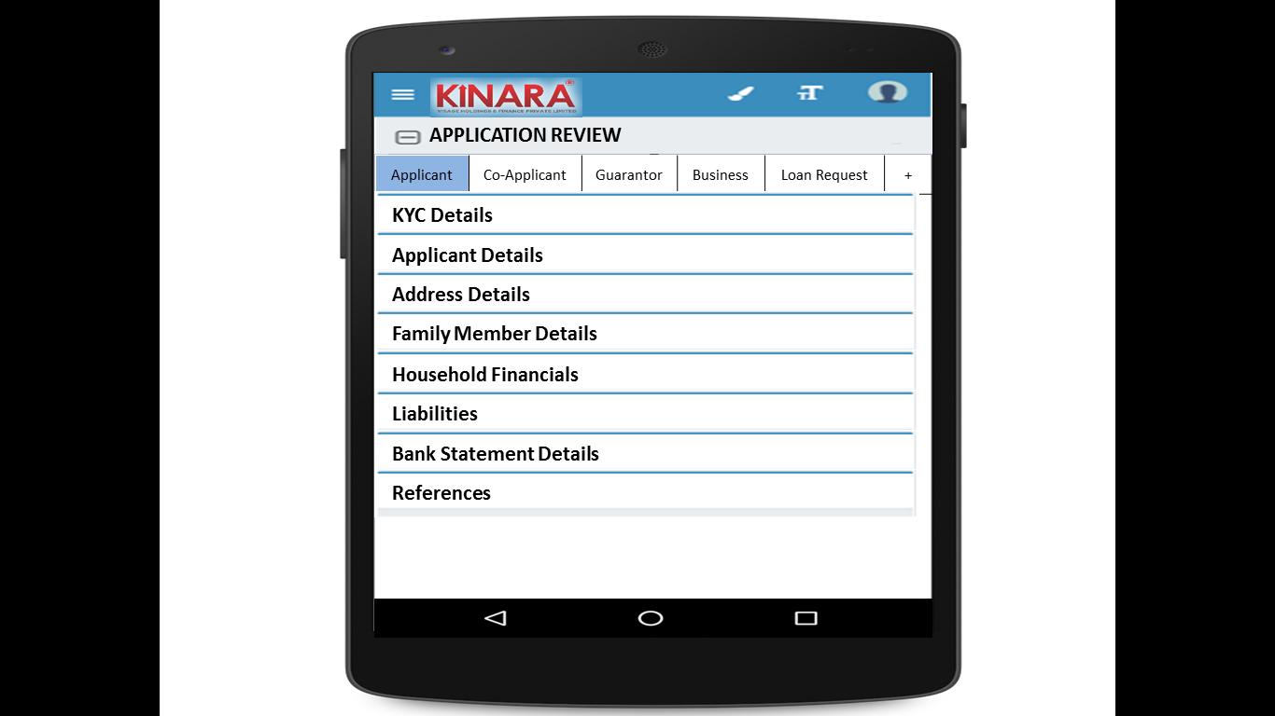

* + - 1. KYC Details:

All details will be auto-populated from application stage

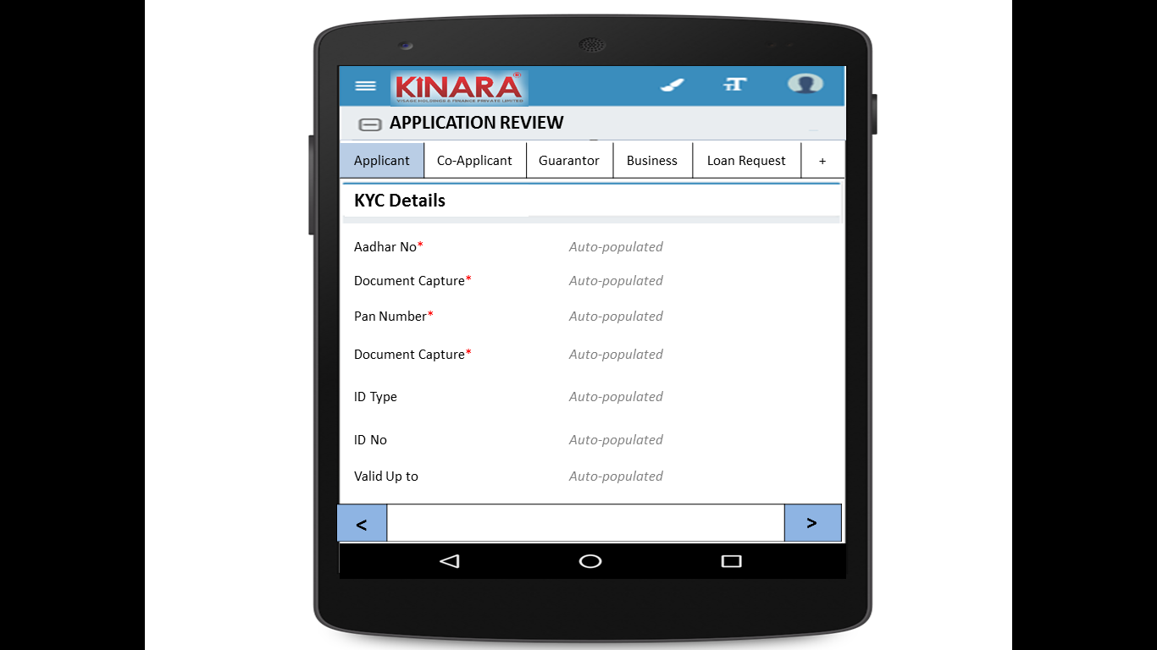

* + - 1. Applicant Details

All details will be auto-populated from application stage

|  |  |  |
| --- | --- | --- |
| Page 1 | Page 2 | Page 3 |

* + - 1. Address Details

All details will be auto-populated from application stage

|  |  |
| --- | --- |
| Page 1 | Page 2 |
| Page 3 | Page 4 |

* + - 1. Family Member Details

All details will be auto-populated from application stage

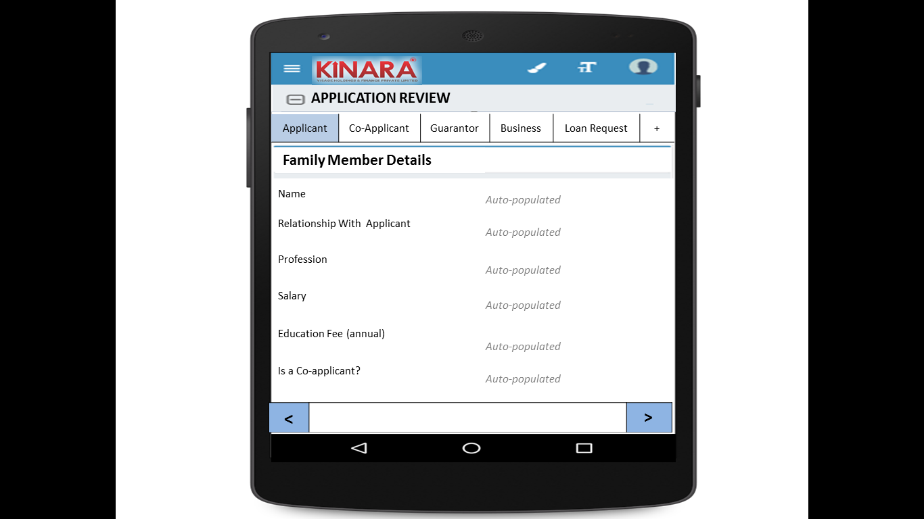

* + - 1. Household Financials

All details will be auto-populated from application stage

|  |  |
| --- | --- |
| Page 1 | Page 2 |

* + - 1. Liabilities

All details will be auto-populated from application stage

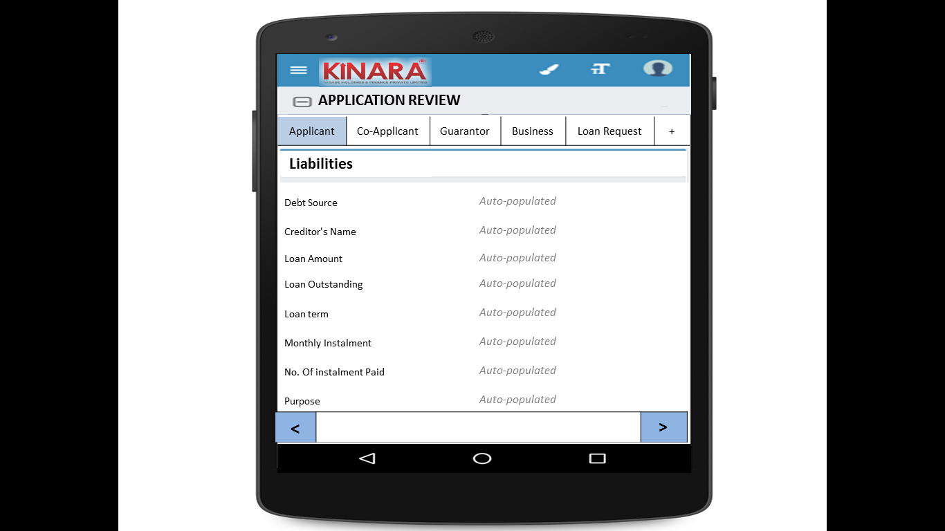

* + - 1. Bank Statement Details

All details will be auto-populated from application stage

|  |  |
| --- | --- |
| Page 1 | Page 2 |

* + - 1. References

All details will be auto-populated from application stage

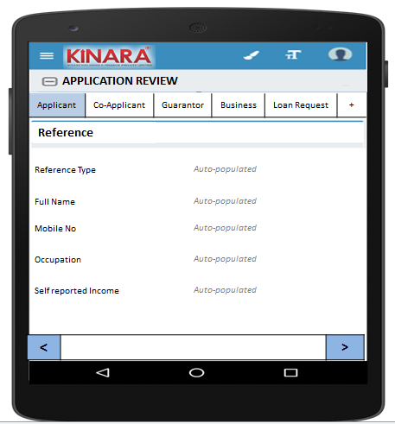

* + 1. **Co-applicant**

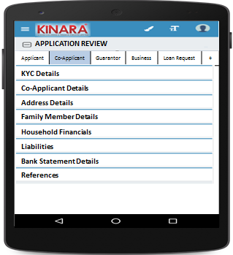

* + - 1. KYC Details

All details will be auto-populated from application stage

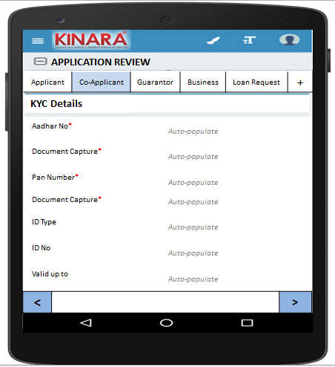

* + - 1. Co-applicant Details

All details will be auto-populated from application stage

|  |  |  |
| --- | --- | --- |
| Page 1 | Page 2 | Page 3 |

* + - 1. Address Details

All details will be auto-populated from application stage

|  |  |
| --- | --- |
| Page 1 | Page 2 |
| Page 3 | Page 4 |

* + - 1. Family Member Details

All details will be auto-populated from application stage

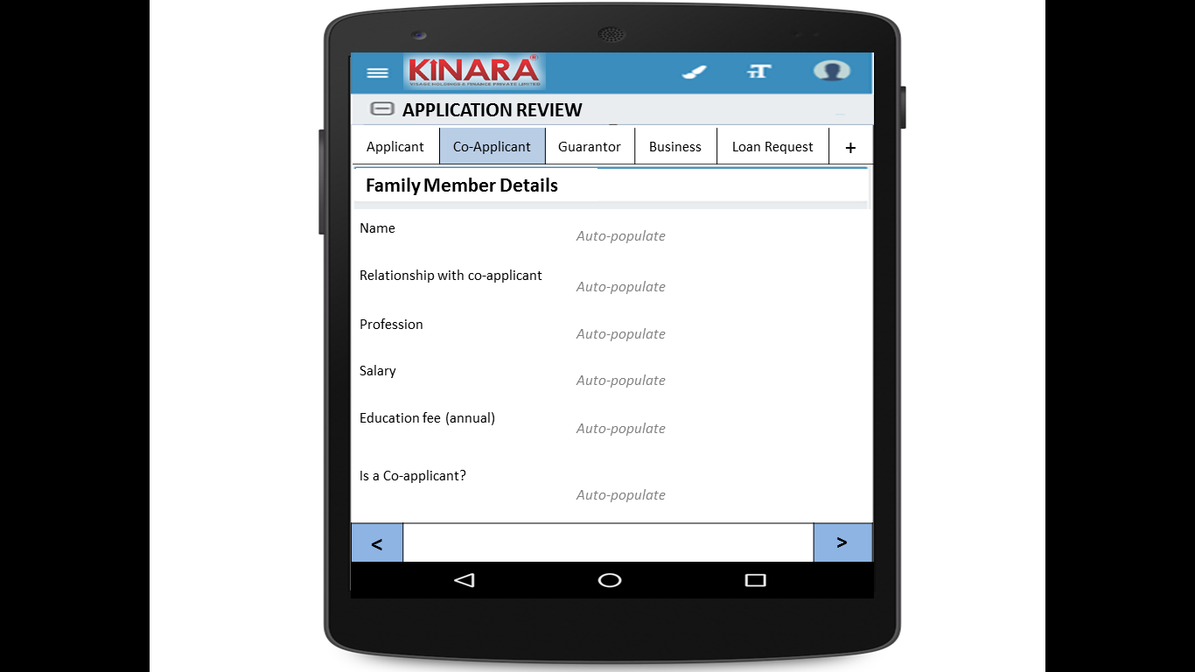

* + - 1. Household Financials  
         All details will be auto-populated from application stage

|  |  |
| --- | --- |
| Page 1 | Page 2 |

* + - 1. Liabilities

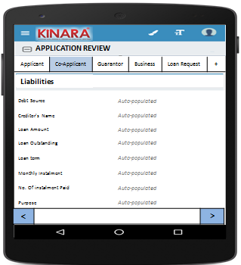

* + - 1. Bank Statement Details

All details will be auto-populated from application stage

|  |  |
| --- | --- |
| Page 1 | Page 2 |

* + 1. **Guarantor**

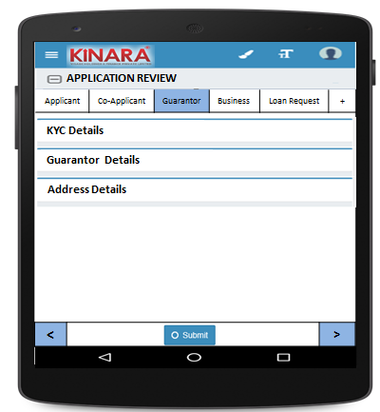

* + - 1. KYC Details

All details will be auto-populated from application stage

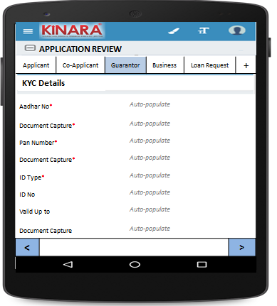

* + - 1. Guarantor Details

All details will be auto-populated from application stage

|  |  |  |
| --- | --- | --- |
| Page 1 | Page 2 | Page 3 |

* + - 1. Address Details

All details will be auto-populated from application stage

|  |  |
| --- | --- |
| Page 1 | Page 2 |
| Page 3 | Page 4 |

* + 1. **Business**

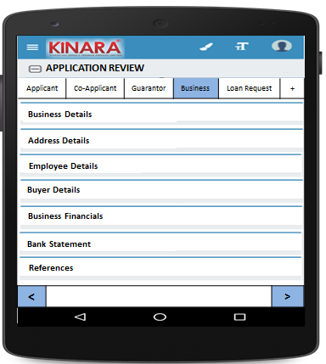

* + - 1. Business Details

All details will be auto-populated from application stage

|  |  |  |
| --- | --- | --- |
| Page 1 | Page 2 | Page 3 |

* + - 1. Address Details

All details will be auto-populated from application stage

|  |  |
| --- | --- |
| Page 1 | Page 2 |

* + - 1. Employee Details

All details will be auto-populated from application stage

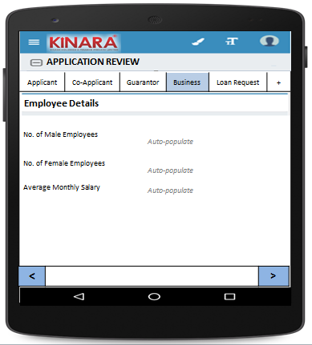

* + - 1. Buyer Details

All details will be auto-populated from application stage

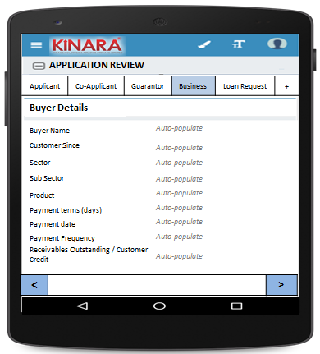

* + - 1. Business Financials

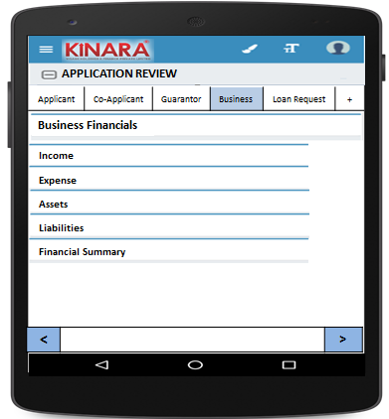

* + - * 1. Income

All details will be auto-populated from application stage

|  |  |
| --- | --- |
| Page 1 – Through Sales | Page 2 – Other Business Income |

* + - * 1. Expense

All details will be auto-populated from application stage

|  |  |
| --- | --- |
| Page 1- Raw material expense | Page 2 – Salary and wages |
| Page 3 – Fixed Obligations | Page 4 – Other Expenses |

* + - * 1. Assets

All details will be auto-populated from application stage

|  |  |
| --- | --- |
| Page 1 – Current Assets | Page 2 – Inventory |
| Page 3 – Machinery (1) | Page 4 – Machinery(2) |
| Page 5 – Other Assets | |

* + - * 1. Liabilities

All details will be auto-populated from application stage

|  |  |
| --- | --- |
| Page 1 – Fixed | Page 2 – Current |

* + - * 1. Financial Summary

All details will be auto-populated from application stage

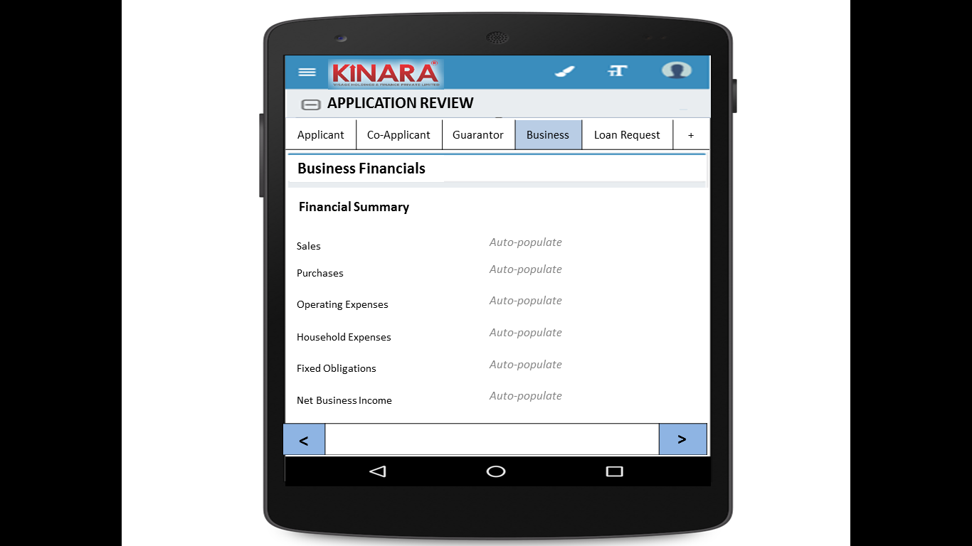

* + - 1. Bank Statement

All details will be auto-populated from application stage

|  |  |
| --- | --- |
| Page 1 | Page 2 |

* + - 1. References

All details will be auto-populated from application stage

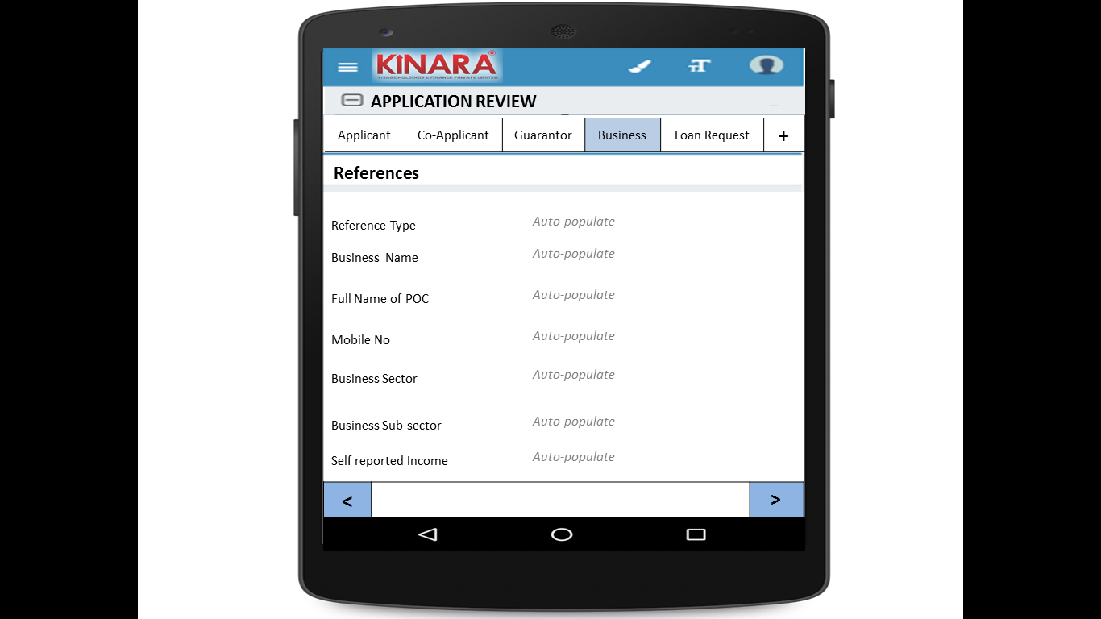

* + 1. **Loan Request**

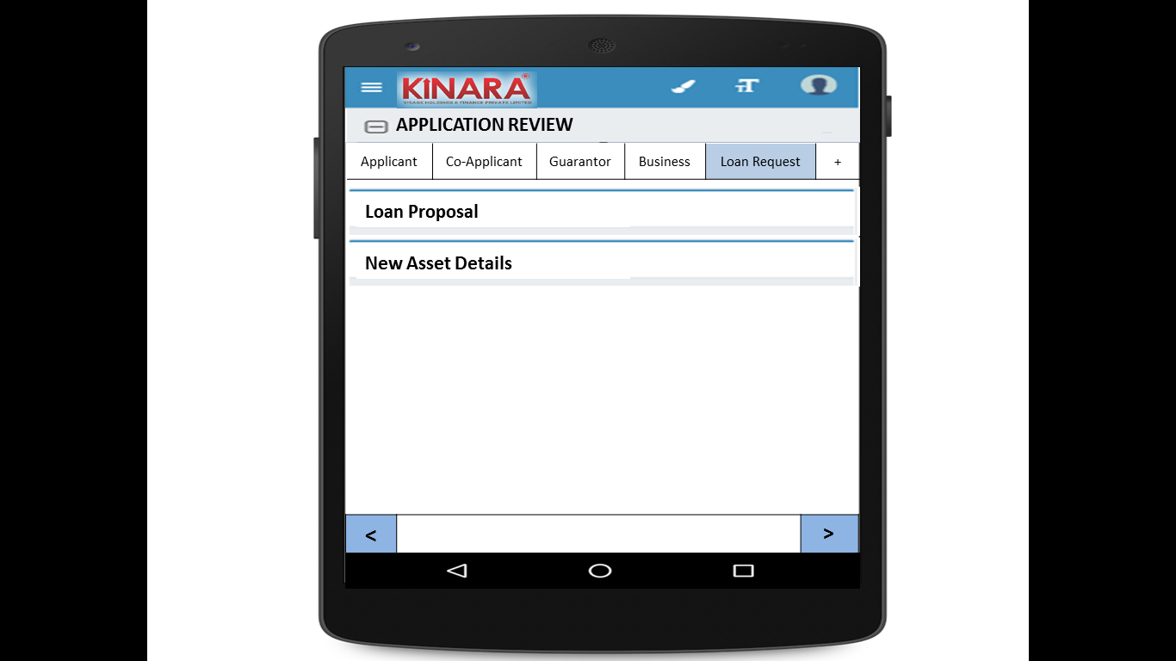

* + - 1. Loan Proposal

All details will be auto-populated from application stage

|  |  |
| --- | --- |
| Page 1 | Page 2 |

* + - 1. New Asset Details

All details will be auto-populated from application stage

|  |  |
| --- | --- |
| Page 1 | Page 2 |

* + 1. Remarks  
       All details will be auto-populated from application stage

|  |  |
| --- | --- |
| Page 1- Click + to add remarks | Page 2 – Enter remarks |

## Functional requirements

* 1. Once the profile is selected from the Application Review Queue, the Hub Manager can view all the data captured and scores tabulated up to the application stage.
  2. Hub Manager will view all data and enter remarks in the end
  3. In case of any deviations, the Hub Manager can send the loan back to any previous stage, or submit.
  4. On clicking ‘send back’ there should be option to choose which stage to send back to
  5. When submitted the loan will automatically move to pending for field appraisal queue

## Uploads

-NA-

## Downloads

-NA-

## Reports

-NA-

# List of Abbreviations

|  |  |
| --- | --- |
|  | **Abbreviations** |
| ABB | Average Bank Balance |
| BRD | Business Requirement Document |
| CB Report | Credit Bureau Report |
| CC | Credit Committee |
| CIBIL | Credit Information Bureau (India) Limited |
| CRM | Central Risk Manager |
| CRO | Credit Risk Officer |
| DO Partner | Direct Origination Partner |
| DPD | Days Past Due |
| DSCR | Debt Servicing Capability Ratio |
| DSO | Days Sales Outstanding |
| EMI | Equated Monthly Instalments |
| FRO | Field Risk Officer |
| HM | Hub Manager |
| ITR | Income Tax Return |
| LCRDS | Line of Credit RFD - Secured |
| LCRDU | Line of Credit RFD - Unsecured |
| LCRIS | Line of Credit RFID - Secured |
| LCRIU | Line of Credit RFID - Unsecured |
| LO | Loan Officer |
| LTV | Loan To Value |
| LUC | Loan Utilisation Check |
| POC | Point of Contact |
| RS 1 | Risk Score 1 |
| RS 2 | Risk Score 2 |
| RS 3 | Risk Score 3 |
| SCAPS | Shriram City Asset Purchase - Secured |
| SCBDS | Shriram City Business Development - Secured |
| SCBDU | Shriram City Business Development - Unsecured |
| SCMFS | Shriram City Machine Refinance - Secured |
| SCWCS | Shriram City Working Capital - Unsecured |
| SCWCU | Shriram City Working Capital - Secured |
| TLAPS | Term Loan Asset Purchase - Secured |
| TLBDS | Term Loan Business Development - Secured |
| TLBDU | Term Loan Business Development - Unsecured |
| TLMFS | Term Loan Machine Refinance - Secured |
| TLWCS | Term Loan Working Capital - Unsecured |
| TLWCU | Term Loan Working Capital - Secured |
| URN | Unique Registration Number |
| WC | Working Capital |